**1 – 7.10 Output**

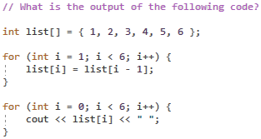

list[1] = list[0] // 1  
list[2] = list[1] // 1  
etc …

**Output:**

1 1 1 1 1 1

**2 – Array Functions**

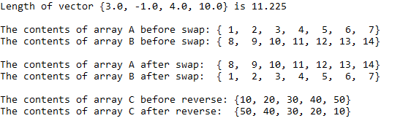

**3 – Array Minimum**



**4 – Temperature Conversions**

